**ONLINE COURSE RESERVATION SYSTEM:**

**Use Case Diagram:**

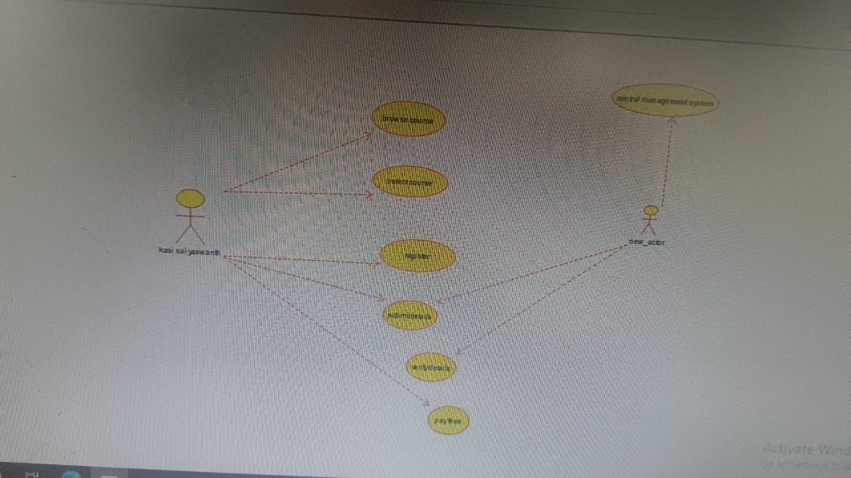

**Class Diagram:**

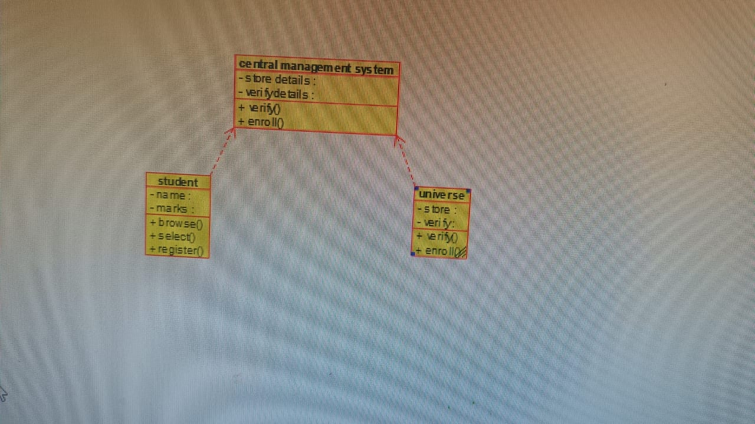

**Activity Diagram:**

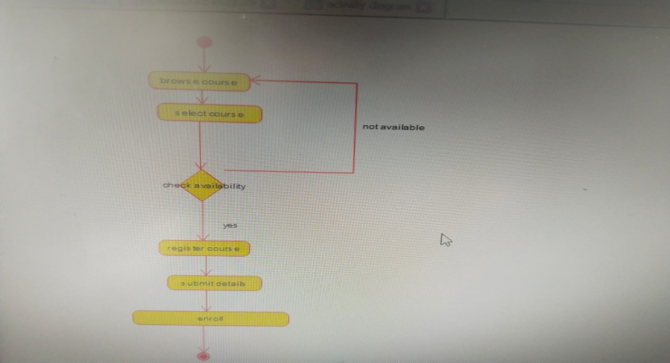

**State Diagram:**

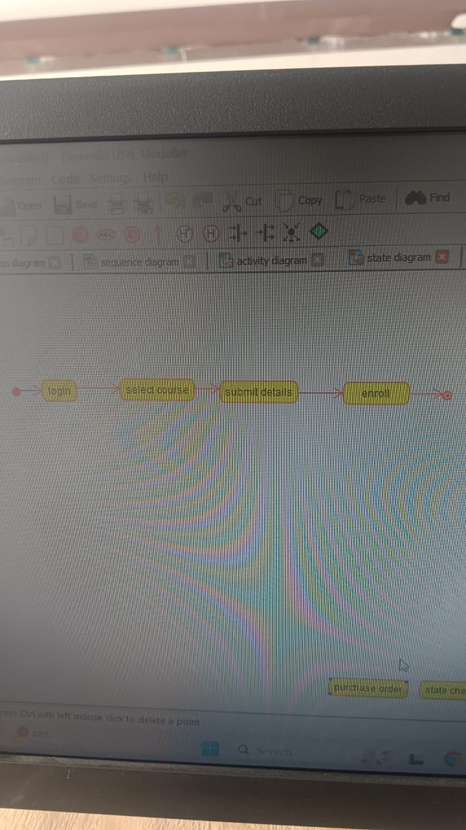

**Sequence Diagram:**

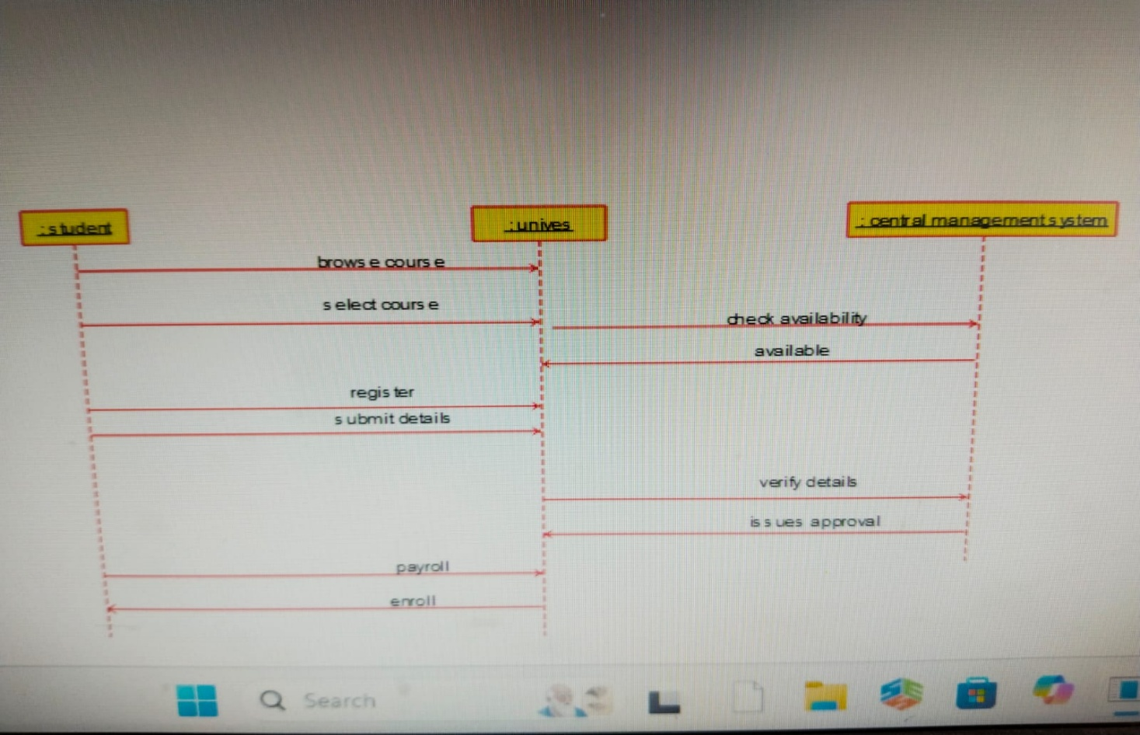

**Component Diagram:**

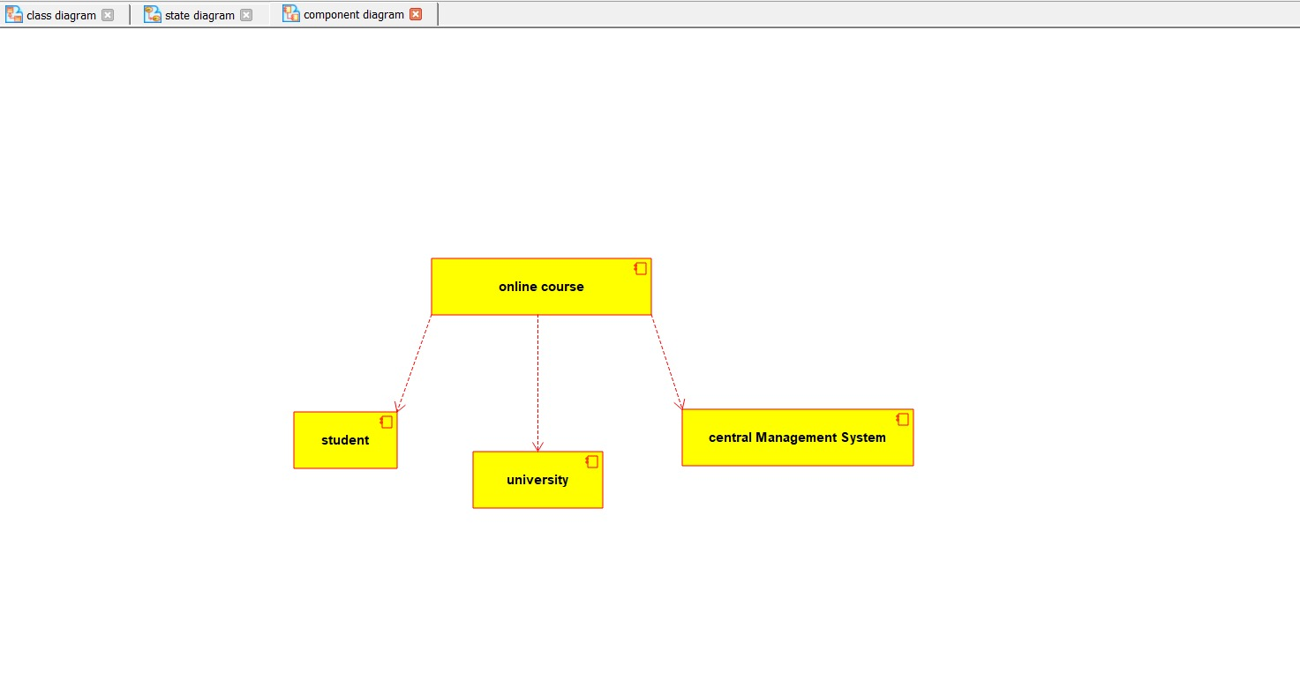

**Deployment Diagram**:

